Attachment C – Locality Map
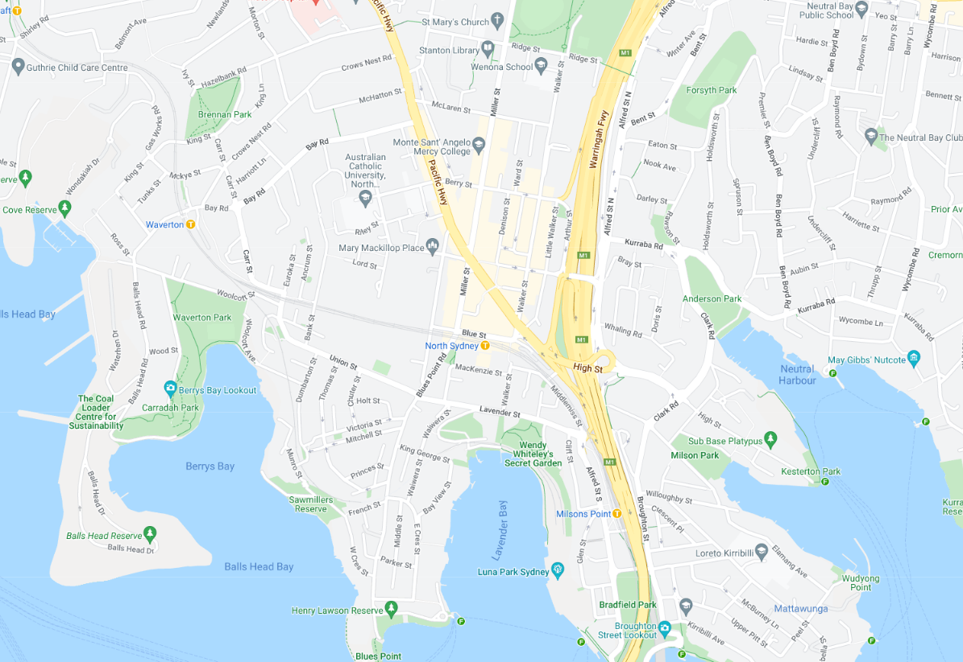
N
Subject Site
Figure 1: Locality (source: Nearmaps)
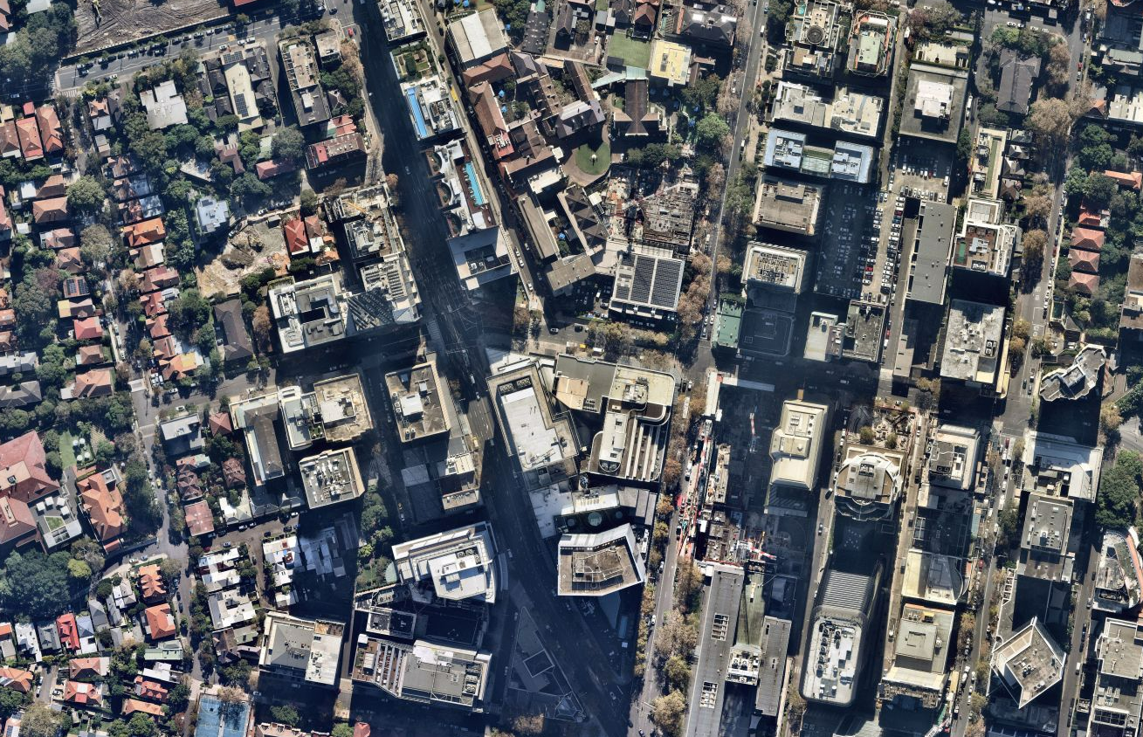
Berry Street
Walker Street
Miller Street
Pacific Highway
Berry Street
N
Angelo Street
Figure 2: Locality (source: Nearmaps)
Pacific Highway

